**11**. Payment info

create table Paymentinfo(Primary key(TransactionId) int NOT NULL ,DateOfPayment DATE);

desc Paymentinfo;

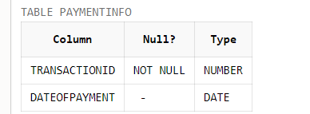

Insertion of Records:

insert into Paymentinfo values ('23422', DATE '2021-12-17');

insert into Paymentinfo values ('22133', DATE '2023-12-11');

insert into Paymentinfo values ('12342', DATE '2132-09-10');

insert into Paymentinfo values ('00987', DATE '2030-10-30');

insert into Paymentinfo values ('24432', DATE '2020-01-01');

Select * from Paymentinfo;

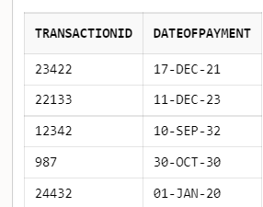

**12.** Search

create table Searzh(foreign key(UserID) references Users(UserID),Searzch varchar(120), Stime timestamp NOT NULL);

desc Searzh;

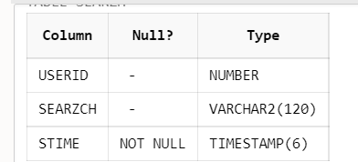

insert into Searzh values ('1001','Disney',timestamp '2020-03-15 19:02:00');

insert into Searzh values ('1002','HotChocolate',timestamp '2017-04-15 12:02:00');

insert into Searzh values ('1003','Amrita',timestamp '2007-10-10 09:22:34');

insert into Searzh values ('1004','youtube',timestamp '2019-04-15 18:42:00');

insert into Searzh values ('1005','Facebook',timestamp '2015-06-30 00:06:00');

select * from Searzh;select * from Searzh;

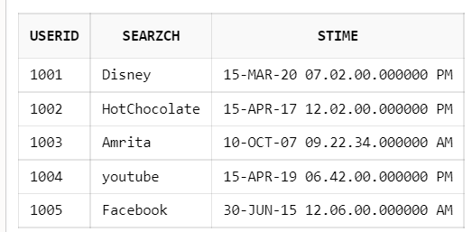

**13. Contact**

create table Contact(primary key(contactid) int,primary key(Username), foreign key(Username) references Admin(Username) varchar(30), mobile_number int);

desc Contact;

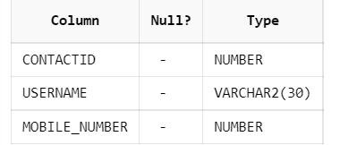

insert into Contact values ('11211','Raghunandhan', '78876765511');

insert into Contact values ('45677','Eren Yeager', '9998887654');

insert into Contact values ('980765','Bruce Wayne', '9442576888');

insert into Contact values ('112113','Bigil', '7708272273');

insert into Contact values ('112115','Raju', '7887332332');

select * from Contact;

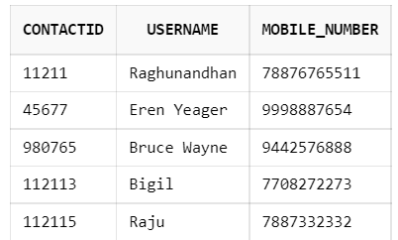

**14.** MultimediaRepository

CREATE TABLE MultimediaRepository(ContentId int, RegUid int, Content_Type varchar(40), Approval_Status varchar(100), Comments varchar(400), primary key(ContentId), foreign key (RegUid) REFERENCES Registered_Users(RegUId));

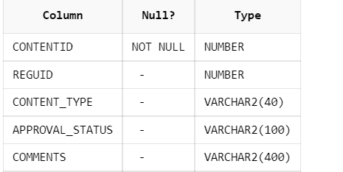

insert into MultimediaRepository values ('4219', '1001' , 'Audio', 'Approved','No comment');

insert into MultimediaRepository values ('2091', '1003' , 'Video', 'Approved','No Comment');

insert into MultimediaRepository values ('1058', '1008' , 'Text', 'Not Approved','Content inappropriate for certain users');

insert into MultimediaRepository values ('3343','1007' , 'Image','Approved','No Comment');

insert into MultimediaRepository values ('4666', '1011' , 'Audio', 'Not Approved','Not good quality Audio');

insert into MultimediaRepository values ('1734', '1014' , 'Text', 'Approved','No Comment');

select * from MultimediaRepository;

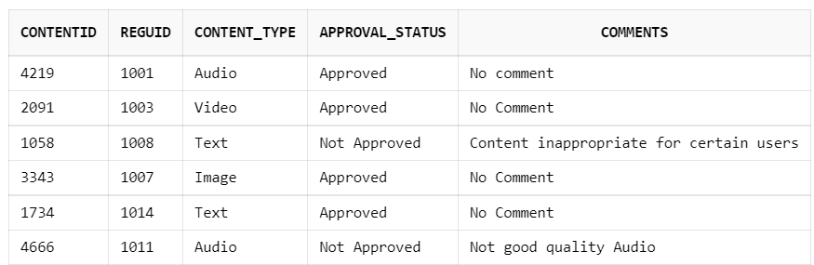

**15. Keyword**

create table keyword( primary key(KeywordID) int, ContentID int, Keyword varchar(30), primary key(ContentID),foreign key (ContentID) REFERENCES Content(ContentID));

desc keyword;

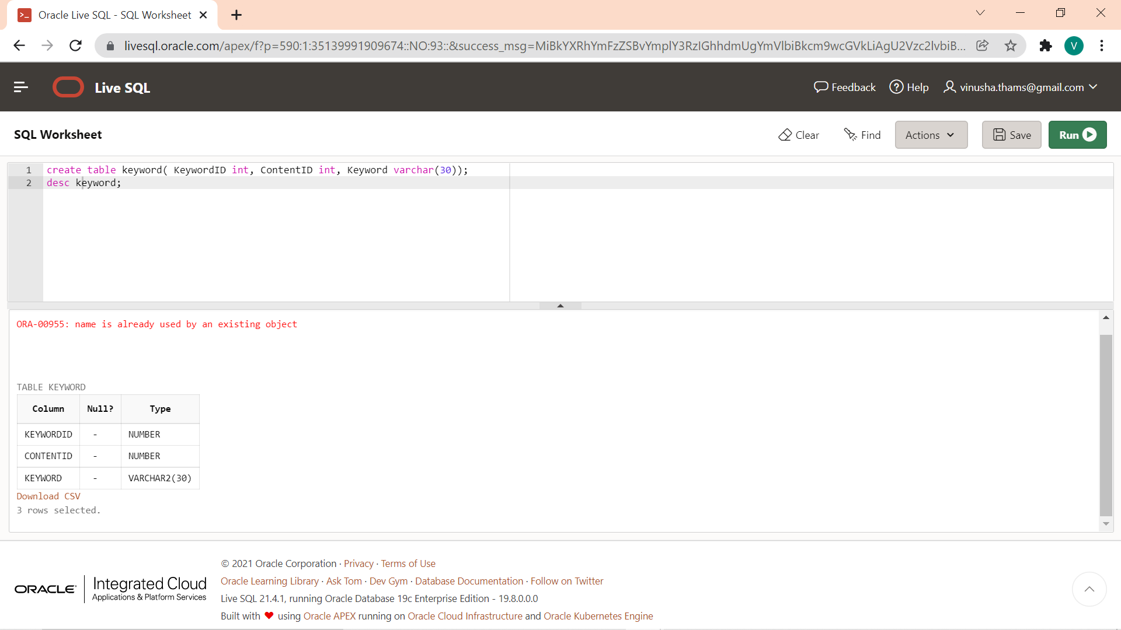

insert into keyword values('23422','4219' ,'disney,cartoon,mickey');

insert into keyword values('23112','2091' ,'Hotchocolate, chocolate, milk');

insert into keyword values('211233','1058' ,'College,amrita');

insert into keyword values('99876','3348' ,'youtube, video');

insert into keyword values('23022','1734' ,'facebook,zucc,face,social media');

select * from keyword;

